Right Accord Private Duty:
- Pull each location’s report from ERSP
- Copy and paste the data (beginning with row 2) onto the provided import spreadsheet
- Add a column on the end of your spreadsheet titled “LaborValue1”
- For everyone in the Sarasota location, enter a “1” in this column
- For everyone in the Venice location, enter a “3” in this column
- Copy and paste the E_Regular_ORRate column into a new column (this can be at the end of your spreadsheet. Rename this new header E_Overtime_ORRate.
- Copy and paste the E_Regular_ORRate column into a new column (this can be at the end of your spreadsheet. Rename this new header E_Holiday 1.5_ORRate.
- Save the spreadsheet in an excel format.

Please note:
New hires must be in iSolved before we can import the spreadsheet.
Employee IDs/Numbers must match between iSolved and ERSP. When you add the new hire in iSolved, you will be provided their employee ID/Number.

How to import into iSolved:
- Once logged into iSolved, navigate to Payroll Processing > Payroll Entry > Timecard Import
- Import type: Timecard, Template: Default, File Format: Excel, Attached file, Default Pay Group: Weekly. Once all is selected, click “Next” on the black bar:

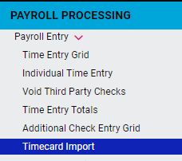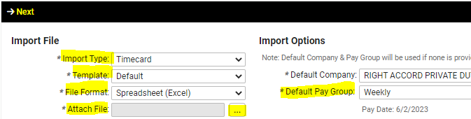
- On the next page, verify there are no critical errors. If there are errors, we cannot move forward. You can view the details by selecting “Click To View Validation Details” at the bottom of your screen:
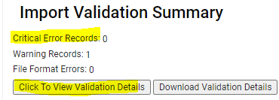
Each week, you will see the following warning. Warnings can be ignored:
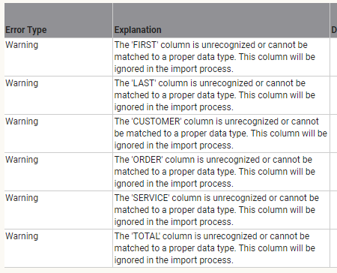

- As long as there are no errors, select “Next” on the black bar to import the hours.

- If you have any additional hours/mileage/reimbursements/etc. that are not on the import spreadsheet, these will need to be added manually after imported. You can use the Individual Time Entry screen to manually import this information:

- Payroll Processing > Payroll Entry > Individual Time Entry
- Select employee’s name
- Use the grid below to enter additional wages
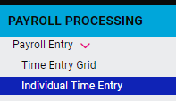
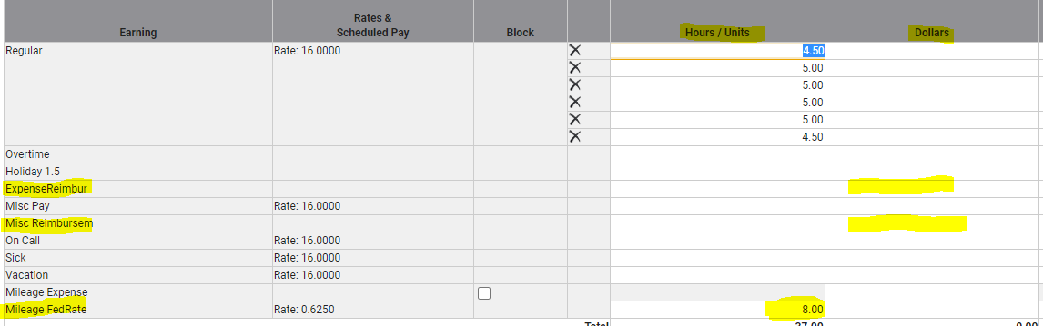
Reimbursements can be entered under Misc Reimbursement (no tax), dollars column.
You can enter Miles using the earning titled “Mileage FedRate” and enter the # of miles under the Hours/Units column.

There is no save button here, everything will auto save, and you can move onto the next employee.

Once all data has been entered, you will then need to go down to Process Payroll from the menu on the left-hand side and select Preview. We recommend reviewing the following reports before processing payroll:
- Current Labor Allocation Detail – This report provides you with a breakdown for each employee, each location (and provides location totals)
- Payroll Summary – Provides you with your total payroll funding and tax breakdown.
- Exceptions – This report provides you with any warnings iSolved is generating. If there is a warning here you are unsure of, please contact our payroll department to verify no changes are needed before processing payroll.

**Once payroll has been processed, no changes can be made. If you have any questions or anything you’d like to verify, please contact our payroll department prior to processing. Anyone in our payroll department will be able to assist you, Monday-Friday from 9am to 5pm**

