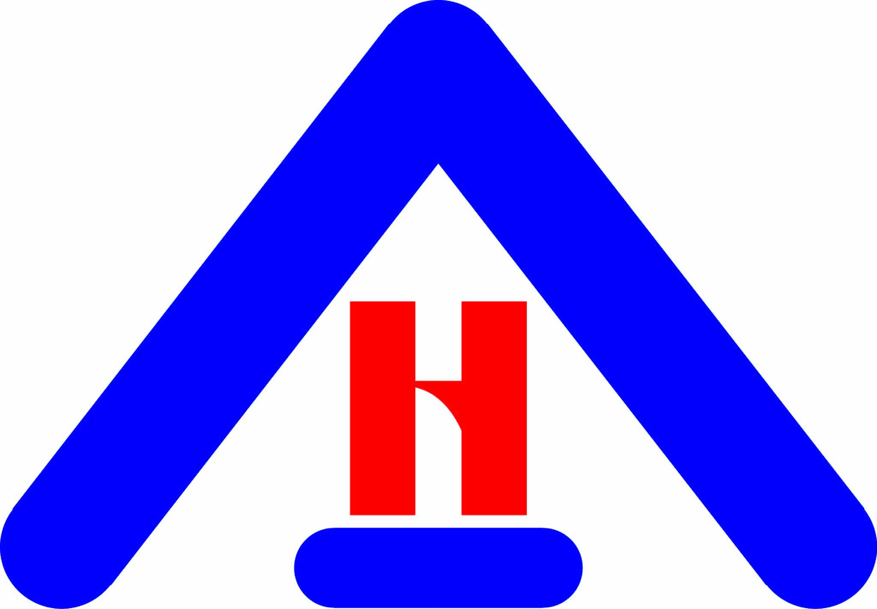**RIGHT ACCORD**

Private Duty – Home Health Care, LLC ~ Health Care Training Center

4071 Bee Ridge Rd, Ste 201, Sarasota, Florida 34233

Tel: (941) 366-0801 available 24/7  Toll Free: 1-877-685-3889  Fax: (941) 240-2145

Email: [admin@rightaccordhealth.com](mailto:admin@rightaccordhealth.com) website: [www.rightaccordhealth.com](http://www.rightaccordhealth.com)

bd83ca8b4222bcaacf735019cbbe3a9b.png

Accredited by

The Joint Commission

June1, 2016

Dear _____________________________:

Right Accord is pleased that you have entrusted your family member in our care to provide homecare giving needs and we are committed in fulfilling your expectations.

Right Accord Services goes beyond “Home Healthcare Private Duty” in the home and so we feel it’s important that you know we can provide recommendations in decision making when it comes to transferring from home to facility care.

We have included our flyers with information on our **Senior Care Advisor** Planning and Decisions. Please take some time to look these over and feel comfortable to call us with any question you have on the topic.

Thanks

*Bernadine Hines*

Assistant Administrator