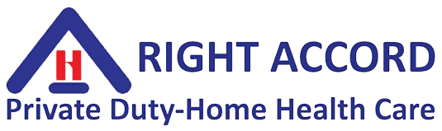

941.366.0801 | www.rightaccordhealth.com
IN THE KNOW – State Mandated Training

Dear Employee,
RIGHT ACCORD provides you access to our “In the Know Training” website while you work with RIGHT ACCORD.
Florida Health Department – Nursing Division, requires you to do these courses. The courses will be noted in your file and you will receive print certificates.
All quizzes must have a pass rate of an 80% and above.
Access website: www.intheknow.com
ID: your-email
PW: your-email

