IN RECOGNITION FOR OUTSTANDING PERFORMANCE IN:
SERVING CLIENTS WITH INTEGRITY

THIS AWARD IS GIVEN TO:

Caregiver name
Thank you for your contribution to RIGHT ACCORD
Private Duty Home Health Care.


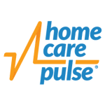
[insert date]
 |  | 
 | [Name, Title] |  | [Name, Title]

