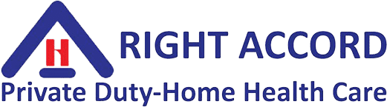
JCAHO NATIONAL PATIENT SAFETY GOALS 2020
National Patient Safety Goal | Application for RIGHT ACCORD Staff
GOAL 7 - Reduce the risk of health care-associated infections  - Comply with current CDC hand-hygiene guidelines    - Manage as sentinel events all identified cases of unidentified death or major permanent loss of function associated with a health care-acquired infection. | CDC Guidelines applications in home care:  Clean Hands Save Lives  - Wash hands upon entering patient’s home  When washing hands with soap and water:  - Wet your hands with clean running water and apply soap. Use warm water if it is available.  - Rub hands together to make a lather and scrub all surfaces.  - Continue rubbing hands for 20 seconds. Need a timer? Hum the "Happy Birthday" song from beginning to end twice.  - Rinse hands well under running water.  - Dry your hands using a paper towel or air dryer. If possible, use your paper towel to turn off the faucet.  When should you wash your hands?  - Before and after preparing food  - Before and after eating food  - After using the toilet  - After changing diapers or cleaning up a child who has used the toilet  - Before and after tending to someone who is sick  - After blowing your nose, coughing, or sneezing  - After handling an animal or animal waste  - After handling garbage  - Before and after treating a cut or wound  Remember: If soap and water are not available, use alcohol-based gel (at least 60% alcohol) to clean hands.  Infections diagnosed while patient is on home care are to be reported on Infection Report  - Submit Infection Report to Case Manager  - Call and submit Occurrence Report to PI Manager/Administrator if patient’s condition, as a result of an infection, causes major permanent loss of function or death.
GOAL 9 – Reduce the risk of patient harm resulting from falls  - Assess and periodically reassess each patient’s risk for falling, including the potential risk associated with the patient’s medication regimen, and take action to address any identified risks.  Date Reviewed: Jan. 1, 2020 | At start of care, assess the patient’s risk for falls including the potential for falls due to med actions or side effects.  - Provide safety instruction including methods to prevent falls  - Educate staff on fall reduction program in time frame determined by the organization  - Educate the patient and family on any individualized fall reduction strategies  - Refer to physical therapy as needed for safety, gait and balance training  - Follow-up to evaluate the effectiveness of the interventions  NAME AND TITLE: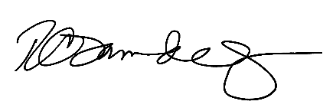  Rosemarie Tamunday-Casanova, RN

